Brant Road

Brant Road
Surgery
0844 8151480

Issue 8
Brant Road Surgery Newsletter

Dear Patient


Welcome to your eighth edition of the ‘Brant Road Surgery Newsletter’.
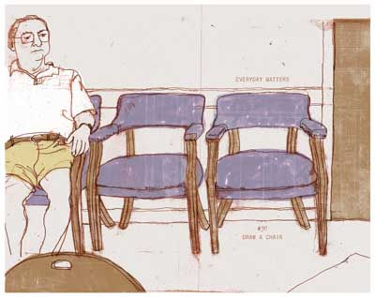

Developments to the Waiting Room

Many responses to our annual patient survey mention the waiting area and ways it could be made more suitable for our growing number of patients.

Following those responses, we are delighted to announce that we put in an application for funding to the Rapid Improvement Fund and have been successful in securing the finance to modernise the patient waiting area. Improvements will include an electronic front door, additional and more comfortable seating, an electronic messaging board and more targeted patient information boards. We are hoping that this work will be completed during March 2009 and there should be little disruption to the waiting area in the meantime.
Extended Hours

Following a questionnaire asking patients for their preferred extension times, we extended our opening until 8.00pm three evenings a week. In times of GPs’ holidays, this is reduced to 2 evenings until 8:15pm. Please be aware that these extra hours were introduced partly to cater for working people who cannot get to the surgery before 6.00pm. If you are offered a late appointment but are able to come during the day please ask if there are other appointments available, and use these where possible.

Cancelling Appointments

You can now cancel your appointment even when the Surgery is closed. If you phone at lunchtime or in the evening you will be given an option to leave a message cancelling your appointment. Please give us as much notice as possible (a minimum of one hour) if you wish to cancel so that the slot can be given to someone else.

During 2008, over 1000 appointments were missed. This is an unacceptable number and in future, patients who repeatedly book appointments which they neither cancel in good time, nor arrive for, will be asked to leave the Practice.

Staff Changes

Practice Manager

Robin Camargo is leaving the Practice after four years in post. She is moving to Brazil with her family and we wish her well for the future.

We are delighted to announce the appointment of Joanne Snell as the new Practice Manager.

Joanne has many years experience in an accountancy practice and more recently in a managerial role at the Bransby Home of Rest for Horses so is well equipped for the demands of running a busy Practice. She will be starting in the middle of March 2009.

Practice Nurse

A warm welcome to Claire Snead our new Practice Nurse. Claire trained in Birmingham with the Royal Navy before working in the acute sector in Plymouth. She decided to make the move to Lincoln and Practice Nursing as she has an interest in the primary care sector. As well as general nursing, Claire is specialising in long term respiratory conditions and is enjoying her new role.

Cancer Patients – Prescription Exemption Rules

From April 2008 people receiving treatment for cancer or the effects of cancer may be entitled to free prescriptions.
New forms are available now. If you are under 60 years old, currently paying for your prescriptions and think this may apply to you, please ask your GP.

Seasonal Ills

An average adult and older child can expect 2-4 colds a year, younger children an average of 3-8. Usually symptoms peak after 2-3 days and then start to ease off, though a cough can linger for up to three weeks. Do not expect your doctor to prescribe antibiotics for colds, or for most coughs and sore throats. All colds and most coughs, sore throats and earaches are caused by viruses, so an antibiotic won’t help. There are usually remedies you can take to relieve the symptoms – ask your pharmacist for advice.

Thank you

The extension to the front of the surgery is now almost complete. We would like to thank everyone for their patience during the disruption.

